CENTRAL EAST INTEGRATED CARE BOARD
WORKWELL INITIATIVE
MINI SPECIFICATION: WORKWELL PILOT DELIVERY

- Background
Central East Integrated Care Board has received a grant from the Department of Work and Pensions (DWP) to deliver WorkWell, an early intervention service providing holistic support to overcome health-related barriers to employment, and a single, joined-up gateway to other support services. WorkWell participants receive person-centred, early support based on their health-related barriers to employment, such as mental health issues, musculoskeletal problems, and other health issues.
Further information on the national programme for WorkWell is available at: WorkWell - GOV.UK (www.gov.uk).
This document invites Expressions of Interest from eligible organisations to deliver small-scale WorkWell pilot activity. It is not a full service specification and is intended to identify suitable delivery partners for short-term pilot mobilisation.
Central East ICB intends to undertake a wider-scale procurement process for the delivery of the WorkWell programme from April 2027 onwards. Participation in this pilot does not guarantee involvement in future delivery arrangements; however, learning from the pilot will be used to inform future commissioning, service design and mobilisation requirements.

- The Pilots
Central East ICB is seeking Expressions of Interest from organisations currently delivering health, care, employment, social prescribing, VCSE or wellbeing services across Hertfordshire and Bedfordshire, Luton and Milton Keynes (BLMK) to support delivery of the WorkWell Pilot Programme. The pilot will support approximately 500 participants between November 2026 and March 2027 and is intended to test the integration of the WorkWell model within existing local services, infrastructure and delivery arrangements. Providers will be expected to utilise existing teams, referral pathways, partnerships and management arrangements wherever possible, rather than establish a standalone service.
The pilot will test and refine local delivery models for WorkWell, helping to establish sustainable community-based services ahead of wider implementation. It will provide primary care teams with practical experience of the WorkWell offer, referral pathways and participant support processes, while strengthening partnerships across health, employment and community services. Learning from the pilot will inform future service development, identify operational requirements and support the scaling of WorkWell across Hertfordshire and BLMK.
2.1 Pilot Objectives
The pilot will:
- Test local referral pathways and demand.
- Test integration with existing neighbourhood and community-based services.
- Develop local partnerships and MDT approaches.
- Generate learning to inform future WorkWell commissioning.
- Support eligible residents to remain in, return to, or access employment.

2.2 What We Are Looking For
The provider must demonstrate:
- An existing service operating within the locality.
- Existing workforce that can incorporate WorkWell activity.
- Established relationships with local health, community, VCSE and employment partners.
- Ability to mobilise rapidly with minimal additional infrastructure.
- Ability to utilise the provided JOY platform and participate in programme evaluation.(Software and training will be provided)

Preference will be given to providers able to embed WorkWell within an existing service model rather than creating a new standalone provision.
2.3 Pilot Requirements
Providers will:
- Accept and screen WorkWell referrals.
- Deliver Work and Health Assessments.
- Develop personalised Return to Work or Thrive at Work plans.
- Provide work and health coaching support.
- Connect participants to existing local support services.
- Attend learning and collaboration sessions organised by the ICB.
- Record activity and outcomes within the designated digital system.
- Contribute to evaluation and service development activities.
- Contribute to reporting against agreed pilot outcomes including participant engagement, employment outcomes, wellbeing outcomes and learning for future service development.

2.4 Expected Scale
Providers should propose:
- The existing service into which WorkWell would be integrated.
- Number of participants they could support.
- Staffing model to be used.
- Funding required.
- How learning from the pilot would inform future delivery.

The ICB intends to award up to eight pilot projects in total, with up to four pilot projects in BLMK and up to four pilot projects in Hertfordshire. The maximum funding available per organisation is £49,999. Providers must ensure that any funding requested does not exceed this amount and represents value for money for the proposed participant numbers and delivery model.

You can express an interest to deliver a pilot in one of more of the below localities.
Table 1 – Existing locality footprints
Bedfordshire, Luton and Milton Keynes
- Bedford Borough
- Central Bedfordshire
- Luton
- Milton Keynes
Hertfordshire
- Central Hertfordshire (North Herts/Stevenage/Welwyn Hatfield)
- Eastern Hertfordshire (Broxbourne/East Herts)
- North West Hertfordshire (Dacorum/St Albans)
- South West Hertfordshire (Hertsmere/Three Rivers/Watford)

The services may be based in physical locations, virtual locations, or a combination of both.

2.5 Indicative Timeline
Milestone | Indicative date
Clarification questions deadline | 22 August 2026
Expression of Interest submission deadline | 2 September 2026
Evaluation and clarification period | September 2026
Pilot award confirmation | Late September 2026
Mobilisation, onboarding and JOY platform training | October 2026
Pilot delivery period | November 2026 to March 2027
Final learning, evaluation and reporting | March to April 2027

Expression of Interest
Please send completed responses to cpicb.cpworkwell@nhs.net by 2nd September
Please contact cpicb.cpworkwell@nhs.net with any clarification questions by 22nd August
Responses will be assessed against the criteria and weightings below. The ICB may seek clarification where required before confirming pilot awards. The ICB reserves the right to undertake proportionate due diligence checks before confirming pilot awards.
1. Existing Service Model (30%)
Please describe the existing service that would host WorkWell activity, including:
- Current client group.
- Locality covered.
- Existing staffing model.
- Annual activity levels.

Maximum 300 words
2. Local Partnerships and Referral Networks (25%)
Please describe your established relationships with:
- Primary care.
- Community services.
- VCSE organisations.
- Employment support services.
- Local authorities.
Maximum 300 words
3. Delivery Proposal (25%)
Please explain how you would incorporate WorkWell into your existing service and support eligible participants. Your response should cover:
- Delivery model: how WorkWell would operate within your existing service and participant pathway.
- Neighbourhood integration: how the proposal would align with neighbourhood health development, particularly MDT community teams.
- Learning and future mobilisation: what you would test through the pilot, how learning would be captured, and how this could inform future mobilisation or wider rollout of WorkWell.
Maximum 500 words
4. Mobilisation and Value for Money (20%)
Please explain:
- How quickly delivery could commence.
- Any additional staffing required.
- Expected participant numbers.
- Funding requested, up to a maximum of £49,999 per organisation.
- How the proposal will support equality of access and contribute to reducing health inequalities, including how delivery will be accessible to underserved groups and how barriers to participation will be identified and addressed.
- Confirmation that appropriate safeguarding and governance arrangements are in place, including safeguarding policies, staff training, DBS arrangements where applicable and information governance/data protection arrangements. Evidence may be requested as part of due diligence before pilot awards are confirmed.
Maximum 400 words

Scoring Scale
- 5 - Excellent: Fully meets requirements with strong evidence and added value.
- 4 - Good: Meets requirements with minor gaps.
- 3 - Satisfactory: Meets requirements but with some limitations.
- 2 - Limited: Partial response with significant gaps.
- 1 - Poor: Minimal evidence provided.
- 0 - Unacceptable: No response or does not meet the requirement.

This approach gives greatest weighting to providers' ability to embed WorkWell within existing local services and partnerships, which is the primary objective of the pilot programme.

Appendix 1 Participant Journey
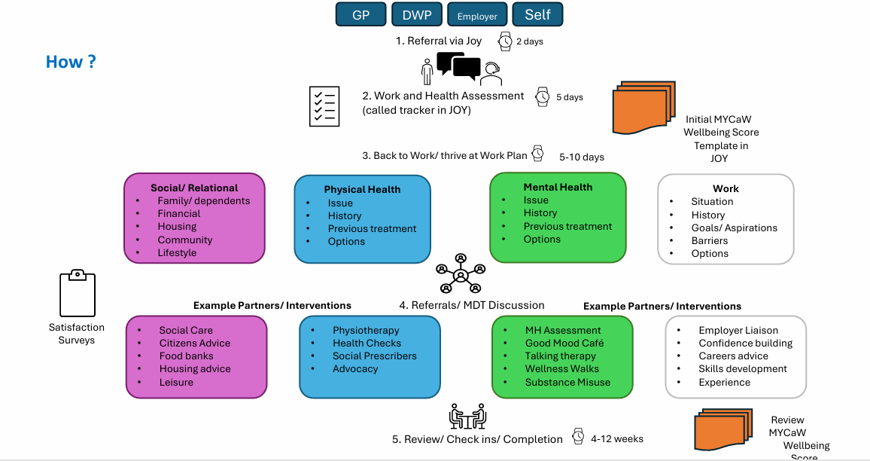
Appendix 2
ELIGIBLE COSTS FOR WORKWELL DELIVERY
(as set out in DWP Grant Agreement with ICB)

- WorkWell service administration costs
- Staffing costs, including recruitment, purchase of laptops or assets maximum value £5,000
- Marketing/advertising, including webpage design
- Training of staff and participants
- Transport costs where a Participant would otherwise be unable to attend employment or training
- Costs associated with providing care for participants
- Costs associated with Disclosure and Barring Service (DBS) checks
- Costs associated with setting up or opening a location specifically to provide a WorkWell service
- Fixed financial contributions to Primary Care Networks
- Fees charged or to be charged to the Grant Recipient by the external auditors/accountants for reporting or certifying that the Grant paid was applied for its intended purposes.
- Payments to a delivery partner for the delivery of a funded activity Giving evidence to Parliamentary Select Committees;
- Attending meetings with government ministers or civil servants to discuss the progress of a taxpayer funded grant scheme;
- Responding to public consultations, where the topic is relevant to the objectives of the Funded Activities. To avoid doubt, Eligible Expenditure does not include the Grant Recipient spending the Grant on lobbying other people to respond to any such consultation (unless explicitly permitted in the Grant Conditions);
- Providing independent, evidence-based policy recommendations to local government, government departments or ministers, where that is the objective of a taxpayer funded grant scheme, for example, ‘What Works Centres’;
- Providing independent evidence-based advice to local or national government as part of the general policy debate, where that is in line with the objectives of the Grant.

Appendix 3
WORK COACH OUTLINE ROLE PROFILE - DRAFT
Role Profile: Work and Health Coach
Location: Central East Integrated Care System

Job Purpose:
The Work and Health Coach is responsible for providing personalised support and guidance to individuals with disabilities or health barriers, helping them to enter, return to, or stay in employment. This role involves assessing clients' needs, developing tailored action plans, and coordinating with employers and other stakeholders to facilitate successful employment outcomes.
Key Responsibilities:
- Assessment and Engagement:
  - Conduct comprehensive assessments to understand participants’ health conditions, skills, experiences, and employment goals.
  - Develop personalised support plans that address specific barriers and outline clear steps towards employment.
- Personalised Coaching and Support:
  - Provide one-on-one coaching to help participants build confidence, enhance their skills, and prepare for employment.
  - Offer ongoing support and motivation, adapting strategies as necessary to meet participants evolving needs.
- Onward Referrals:
  - Identify and connect participants to suitable employment support organisations to support participants with training, skills development and job opportunities that align with participants abilities and aspirations.
  - Liaise with employers and employment support organisations to facilitate reasonable adjustments, ensuring that workplace support is in place.
- Employer Liaison:
  - Build and maintain relationships with local employers, advocating for the hiring of individuals with disabilities or health barriers.
  - Provide employers with guidance on creating inclusive workplaces and making reasonable adjustments.
- Multi-Disciplinary Working:
  - Work closely with health and care providers and other support services to coordinate comprehensive care for participants, attending and contributing to multi-disciplinary team meetings.
- Monitoring and Evaluation:
  - Track participants progress towards goals, maintaining accurate and up-to-date records in Joy Social Prescribing Platform.
  - Evaluate the effectiveness of support plans and interventions, making adjustments to improve outcomes.
- Compliance and Best Practices:
  - Stay informed about relevant legislation, policies, and best practices related to disability employment and workplace accommodations.
  - Ensure all activities comply with legal and organisational standards.
Key Skills and Competencies:
- Empathy and Understanding: Ability to connect with clients empathetically, understanding their unique challenges and needs.
- Communication: Strong verbal and written communication skills, with the ability to clearly articulate ideas and instructions.
- Problem-Solving: Proactive approach to identifying solutions and overcoming barriers to employment.
- Organisational Skills: Excellent organizational and time management skills, with the ability to manage a caseload effectively.
- Adaptability: Flexibility to adapt strategies and approaches based on individual client needs and circumstances.
- Collaboration: Ability to work collaboratively with a diverse range of stakeholders, including clients, employers, and healthcare providers.
Qualifications and Experience:
- Education: Relevant qualification or experience in customer service, community engagement, health, social care, or a related field.
- Experience: Demonstrated experience in supporting people with social needs to access help and support.
- Knowledge: Understanding of personalised care approaches, coaching and /or motivational interviewing methodology, employment legislation and welfare/ benefits and national and local services and support.
- Training: Personalised Care Institute; Core Skills; Shared Decision Making; Personalised Care & Support Planning. See Your learning options (personalisedcareinstitute.org.uk)
- Health Education England E-Learning for Health Platform’s Person Centred Approaches Programme, which is 6 hours in length Social Prescribing – elearning for healthcare (e-lfh.org.uk)
- Health Education England E-Learning for Health Platform’s Person Centred Approaches Programme, which is 5 hours in length, see Person-Centred Approaches – elearning for healthcare (e-lfh.org.uk)
- Making Every Contact Count training
- Two Day accredited tailored Health Coaching for health and social care professionals (Personalised Care Institute) MYCaW Training,/ Digital App training and other Personalised Care Training identified as beneficial during the life of the contract.
- Training in the use of the digital software to capture the DWP reporting requirements.

